Assignment 1 :- Create an IAM user with username of your own wish and grant  
administrator policy.

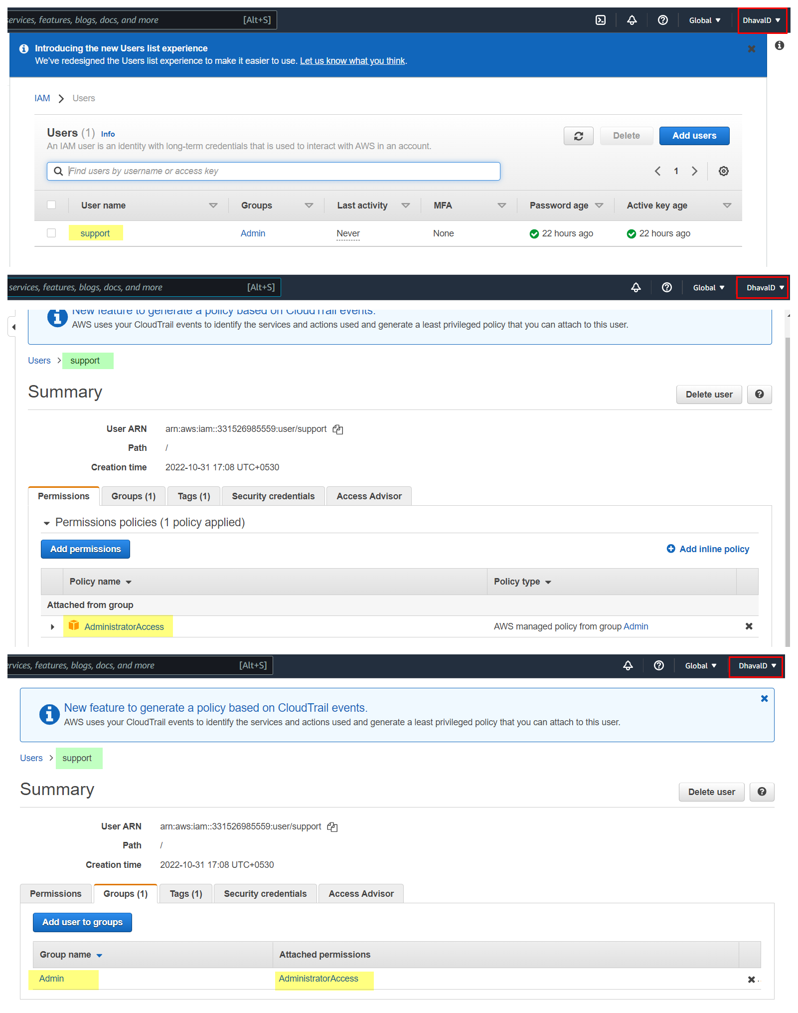

Assignment 2 :- Hello students, in this assignment you need to prepare a  
developers team of avengers.  
- Create 3 IAM users of avengers and assign them in developer’s groups with  
IAM policy.

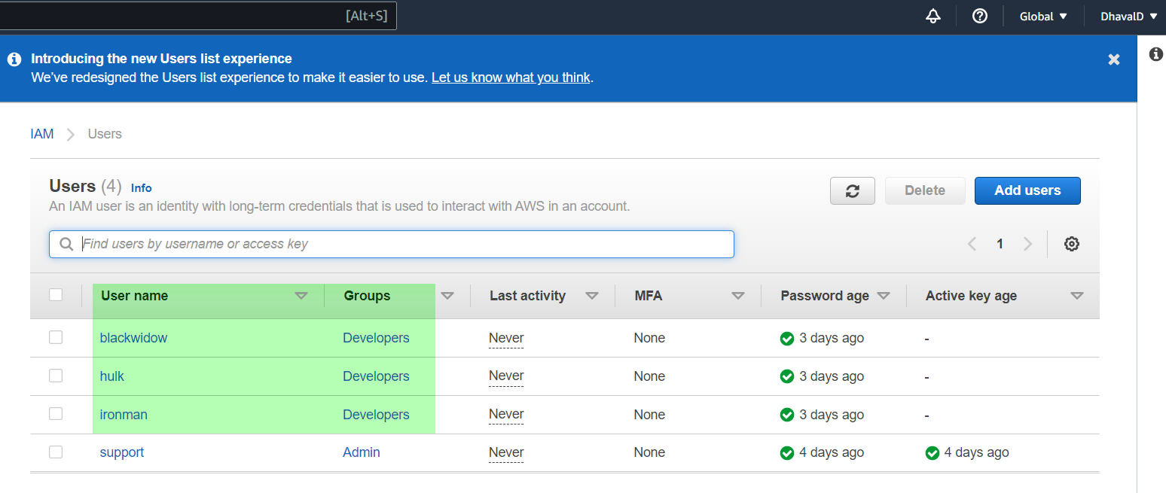

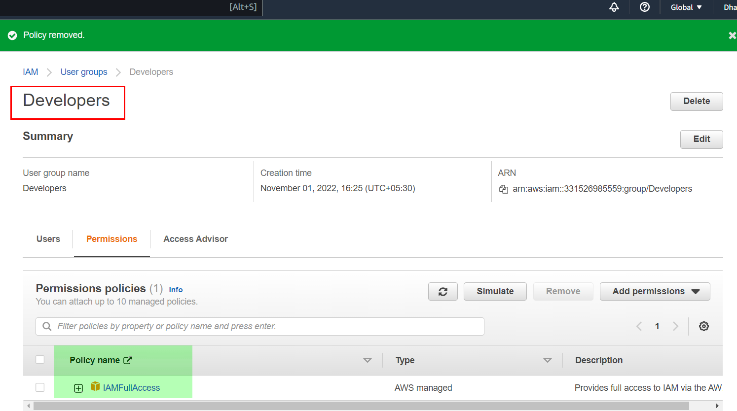

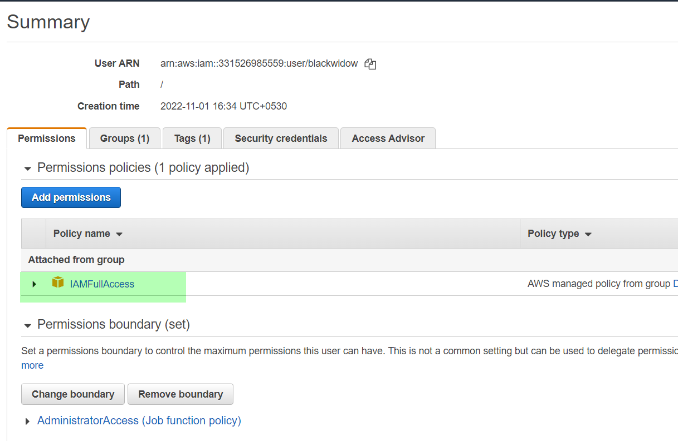

**Assignment 3** :- Define a condition in policy for expiration like  
"DateGreaterThan": {"aws:CurrentTime":  
"2020-04-01T00:00:00Z"},  
"DateLessThan": {"aws:CurrentTime":  
"2020-06-30T23:59:59Z"}  
Define the span of 4 months as per your wish